Field Force Reports

This module to view the field force associates daily generated list per day. The order he made, the bill value he did and all the required details like TBV(Total Bill Value), UOB (Unique Outlets Billed), ABV(Average Bill Value), TLC(Total Lines Cut), ULC(Unique Lines Cut), Delivered Margin and many other values  
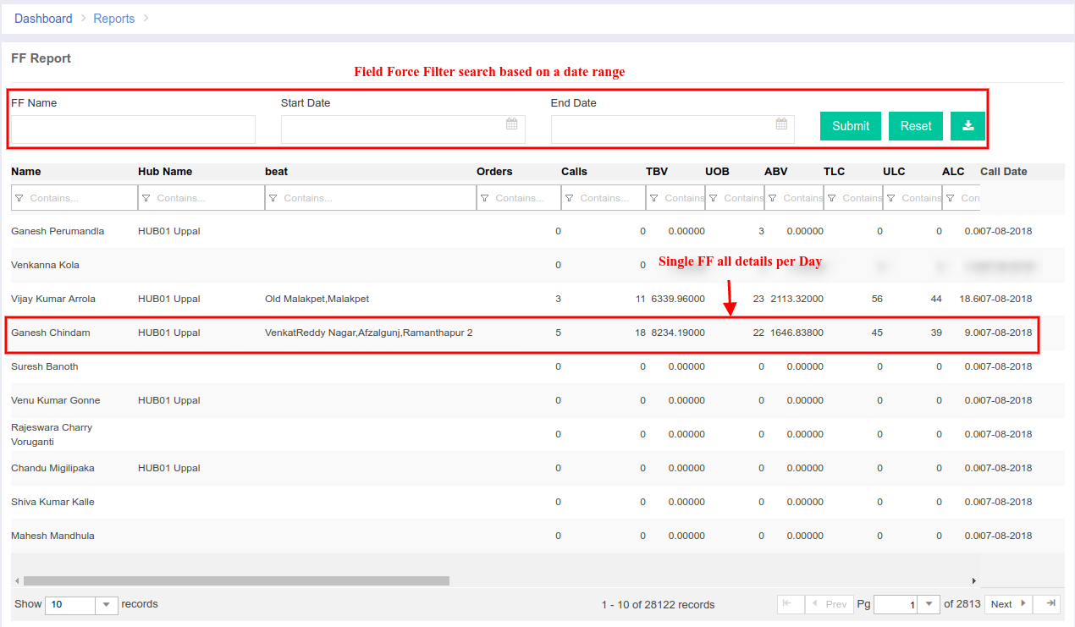  
  
Daily Log Report:   
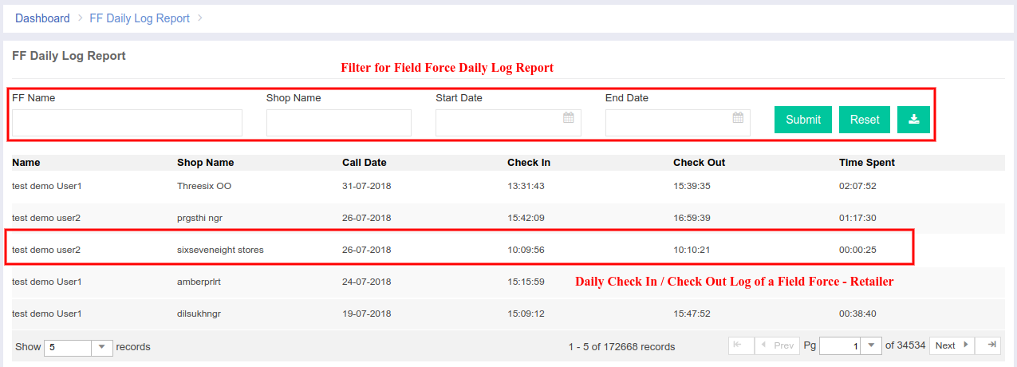

All the detailed information regarding the Field Force Associate's, Field Force Managers and Sales Agents are shown here. This module is completely built for the field force employees. The salaries and commission is decided for field force employees with this module.  
  
Code Details:  
Module Name: **FieldForce and FFReportData**URL: <https://portal.ebutor.com/ffreports> & <https://portal.ebutor.com/ffreportsdata>  
Database: **ff_target** and **ff_call_logs** table  
Feautres:

View FF Page Permission [FFT001]  
 Add FF Target Permission [FFT004]  
 Delete FF Target Permission [FFT003]